Auto Insurance Policy Records

Topic - Decision tree(Chad Analysis

Objective :- to identify the probability of non defaulter customers in a group who have paid the premium on time.

Justification :- Since, the dependent variable is qualitative in nature so we will use the chad analysis

Data Analysis :-

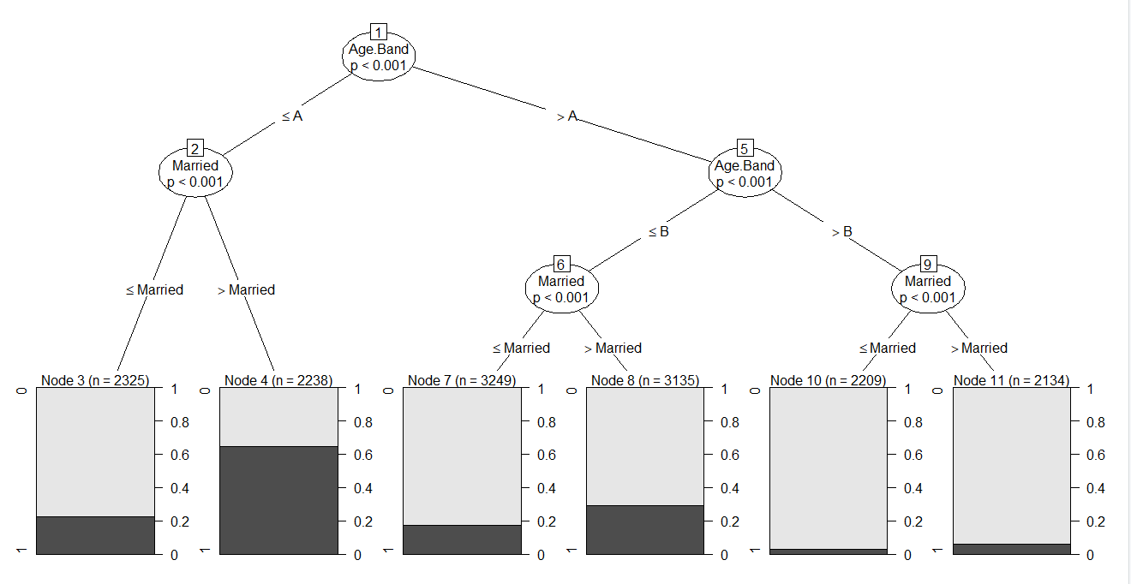

Node3 - Customers belongs to age group A at they are married, their probability of non defaulter is 0.2

Node 4 - Customers belongs to the age group A and they are single, their probability of non defaulters is more than 0.6

Node 7 - Customer belongs to age group B and they are married, their probability of non defaulter is less than 0.2

Node 8 - Customer belongs to age group B and they are Single, their probability of non defaulter is more than 0.2

Node 10 - Customer belongs to age group C and they are married, their probability of non defaulter is less than 0.1

Node 11 - Customer belongs to age group C and they are Single, their probability of non defaulter is more than Node 11

CART Analysis

Objective :- To calculate the average losses (Dependent variables) for different different groups with the help of decision tree

Justification :- Since the dependent variables is losses is quantitative in nature therefore we will use the cart analysis. Cart analysis is based on regression method therefore, we are able to calculate average losses for different different groups

Data analysis :-

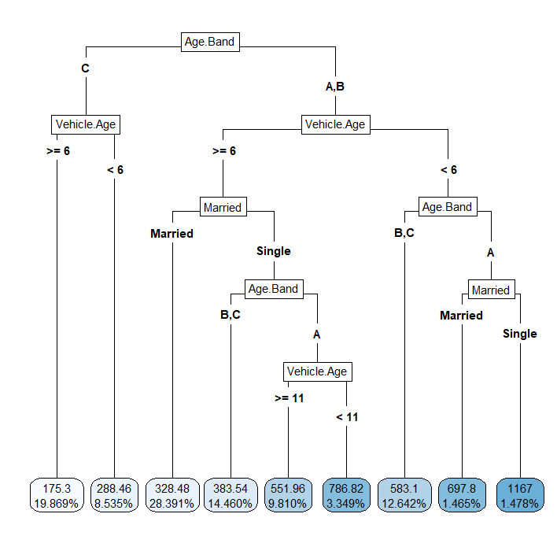

* Firstly the variable is going to be split in two branches, in one branch we have the customers oh age group C and in another group the customers belong to age group A&B
* FUrther Age group C customers going to be classified with respect to the vehicle age in two groups, one group has the vehicle more than = 6 and other has vehicle less than 6
* The average losses for the group (age band = C, vehicle age>= 6) is $175.3
* The average losses for the age group C and vehicle <6 is $288.45